DJango Notes

Architecture of webapplication:

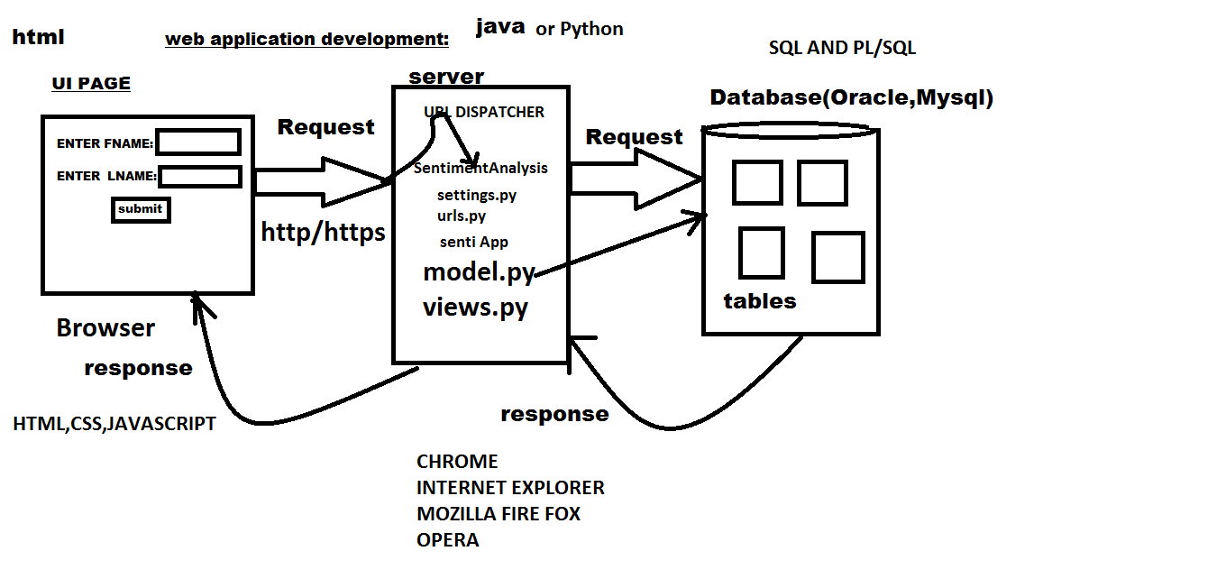

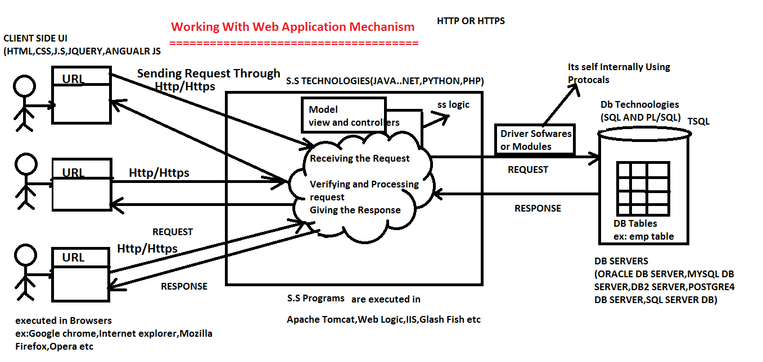

Browsers======>GoogleChrome,MozillaFireFox,

Opera etc

U.I Technologies====>Html,css,JavaScript,Angular Js,Node JS etc.

MiddleWareServer====>ApacheTomcat,GlassFish,IIS etc.

ServerSideTechnologies===>JAVA,.NET,PYTHON,PHP etc

Dbservers====>Oracle,MySql,Db2 etc

DbTechnologies===>SQL,PL/SQL etc.

End user can send the request to the server side application through the browser in

3 ways.

*)By typing url

*)By clicking hyperlinks

*)By Submitting Forms

When ever end user send the request communication takes place between browser to the server side application through the http or https protocol.

server side application will receive the request,process the request and gives the

response to the browser.

while processing the client request server side application can communicate with the database server if it is required.

communication takes place between server side program to the database server through

the driver software(java) or modules(python).

Inorder to develop the web application we required different technologies like

(U.I.T,S.ST,D.B.T).

UI Technologies are used to develop the webpages and also used to perform the Client

Side Validations.

Different UI Technologies are (html,css,javascript,jquery,angular js,node js soon.

Html Programs purpose of Execution done by Html Parsers.

UI Technologies Programs can be executed through the browser softwares.

Different Browser softwares are google chrome,Internet Explorer,Opera soon.

Server side technologies are used to process the client request and it will implement

the business logies.

Different Server technologies are java,.net,php,python etc).

Server side technologies programs are executed through the middle ware servers.

Different Middle ware server softwares are:

1)Apache Tomcat

2)Weblogic

3)Glash Fish

4)I.I.S

5)Django Development Server and soon.

Database technologies are used to store the data in to the database servers.

Different Dtabase Technologies are:

*)SQL

*)PL/SQL

*)DYNAMIC SQL soon.

Different Db Servers are :

*)Oracle

*)Mysql

*)Db2

*)Postgres Sql soon.

What is a Website?

*)Collection of webpages is known as Website.

*)Every Webpage is recognized with url.

**Web Application**:

Every web application is recommended to develop according to MVT===>MVC Design Pattern.

If we do not develop or design every web application according to the MVC design pattern

then we will face the following problems.

Parallel Development is not possible.

code generation tool cannot utilized in efficient manner.

Development time and cost will be increased.

Maintanance or Enhancement becomes difficult.

**FrameWork**:

Every Framework itself is a project implemeted by using programming languages,which

allows you to develop the applications in fast manner.

**Differnent Varities of Frameworks**:

Differnent Varities of Frameworks are used to develop Differnent Varities of Applications.

Different Varities of Frameworks are:

*)Web Frameworks

*)Big Data Frameworks(Hadoop)

*)Testing Frameworks(Selenium)

*)**Web Frameworks**:

Web Frameworks are used to develop the web applications according to the MVC or MVT design pattern.

Every Programming languages contains defferent web frameworks.

**Example**:

Java(Spring,Hibernate),.NET(MVC framework),Python(Django,flask,web2py,bottle,pyramid,googleapp engine).

**Django**:

Django is a framework means it is a project implemented by using python languages.

what is a framework?

By using this django framework which we can develop the web applications according to MVT design Pattern.

Currently Django Framework is maintained by an Open Community and Non-Profitable

Organization called Django Software Foundation.

MVT===>MODEL VIEW TEMPLATE====>PYTHON

MVC=====>MODEL VIEW CONTROLLER====>JAVA AND .NET

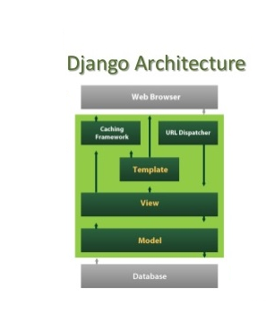

*)What is Virtual Environment? How to download and Create a Virtual Environment for Project?

A)Virtual Environment is a tool to keep the dependencies required by different projects in separate places, by creating virtual Python environments for them.

virtualenv is a tool to create isolated Python environments.

virtualenv creates a folder which contains all the necessary executables to use the packages that a Python project would need.

**Directory Structure Of Django Project**:

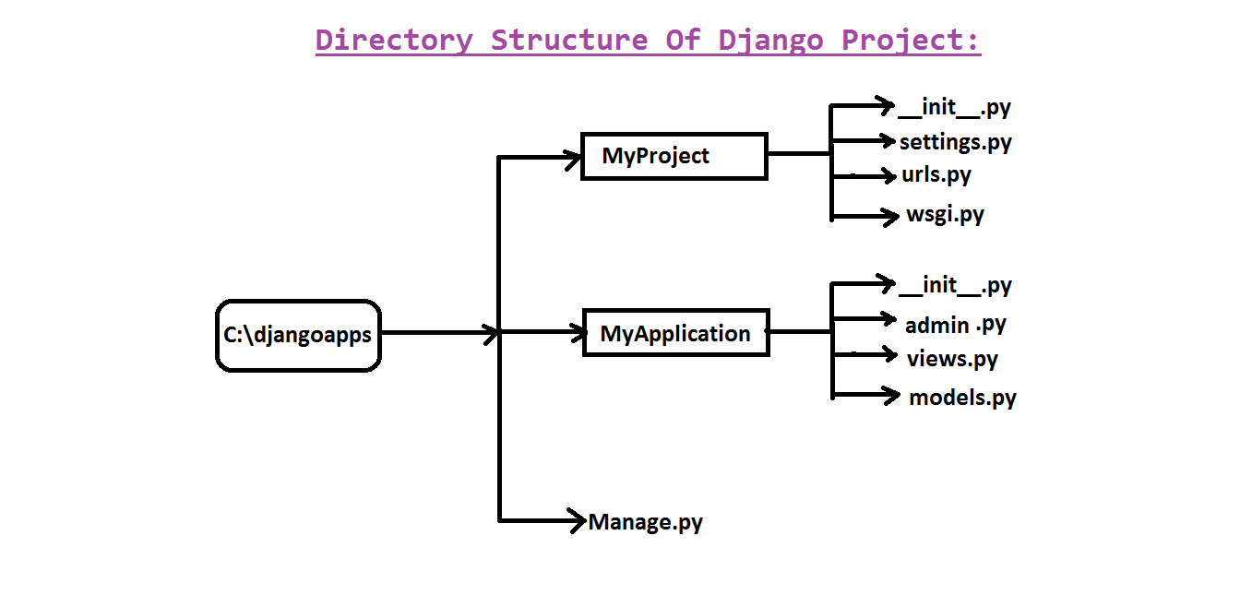

A Django package contains the following packages and files. The outer directory is just a container for the application.

**manage.py:**

It is a command-line utility which allows us to interact with project in various ways and also used to manage application that we will see later on in this tutorial.

* A directory (djangpapp) located inside, is the actual application package name. Its name is the Python package name which we'll need to use to import anything inside the application.
* **__init__.py:** It is an empty file that tells to the Python that this directory should be considered as a Python package.
* **settings.py:** This file is used to provide application settings such as database connection, static files linking etc.
* **urls.py:** This file contains the listed URLs of the application. In this file, we can mention the urls and corresponding actions to perform the task and display the view.
* **wsgi.py:** It is an entry-point for WSGI-compatible web servers to serve Django project.

**Views:**

A view is python function or python class which receives HttpRequest and process the request and gives the HttpResponse.

Every View function or class should be registered with a url pattern.

**Creating 2nd Django Project Using Views and urls files:**

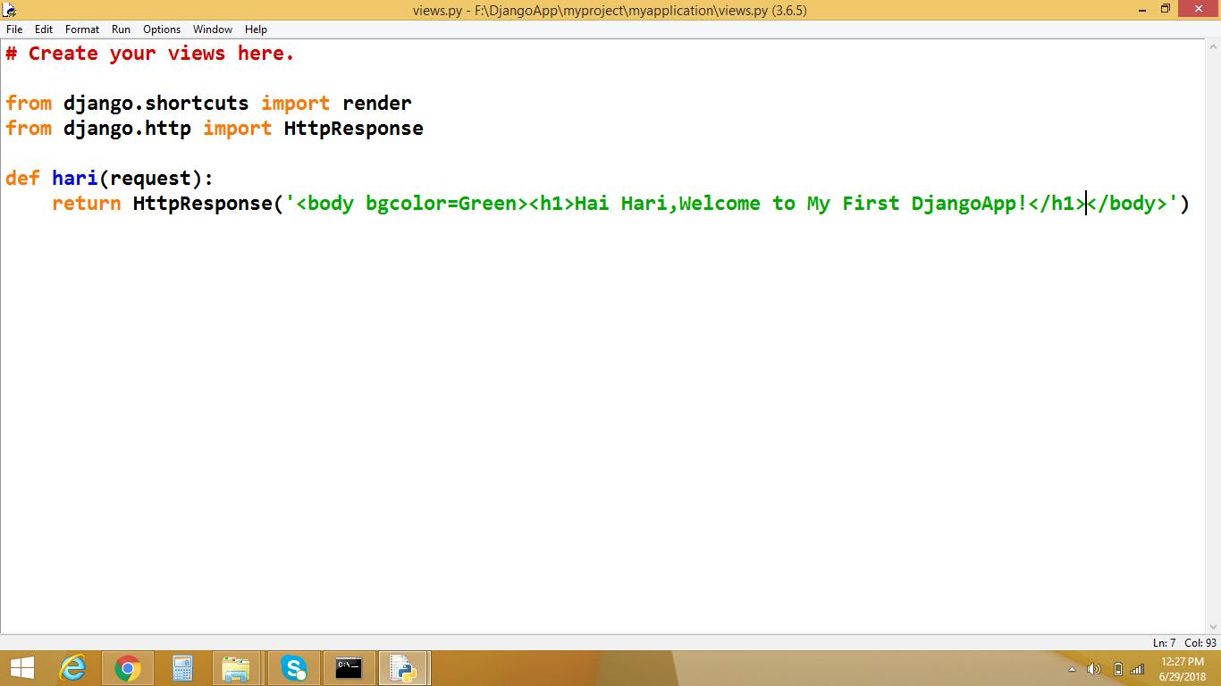

**urls:**

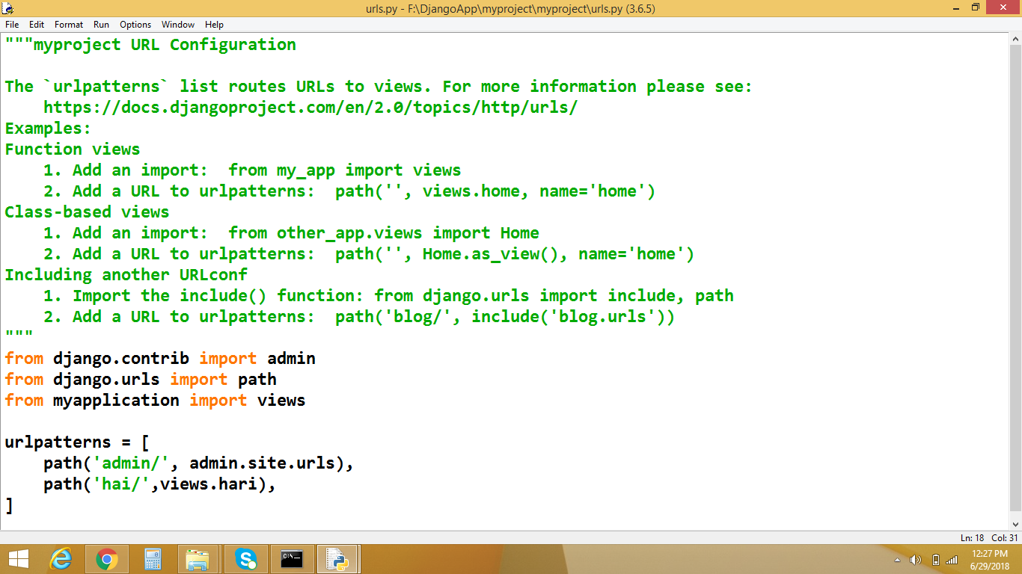

**2ND DjangoProject:**

**Views.py**

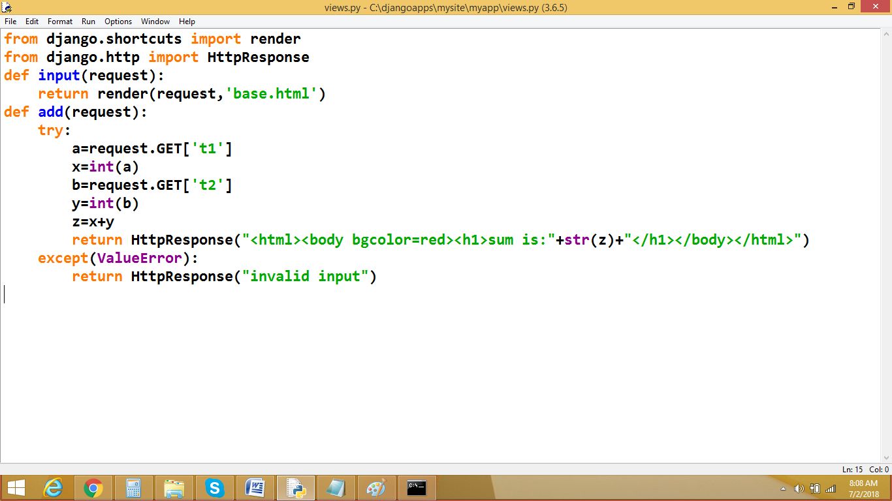

**2)urls.py:**

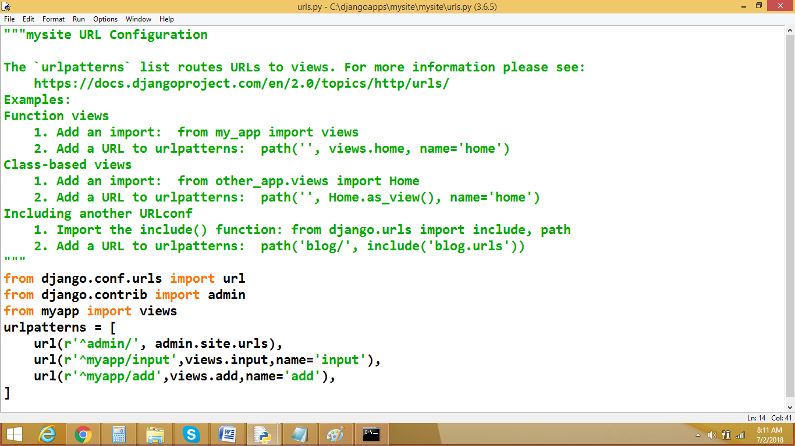

**3)base.html:**

